

**Course Title:Electrical Circuits**

**Course:CSE251**

**Lab Report (6)**

**Section: 5**

**Date: 12.1.22**

**Experiment Title:** Measurement of Parameters and I-V characteristics of an N-channel MOSFET.

**Submitted by:**

Student name:Md.Abu Zafor

Student Id:2020-2-60-158

**Submitted to:**

Touhid Ahmed

Lecturer Department of Computer Science & Engineering

**Title:** Measurement of Parameters and I-V characteristics of an N-channel MOSFET.

**Objectives:**

1.To measure the threshold voltage Vt and the process transconductance Kn of an N-channel

enhancement type MOSFET.

2. To measure the I-V characteristics (ID vs. VDS) of an N-channel enhancement type MOSFET.

**Circuit Diagram:**

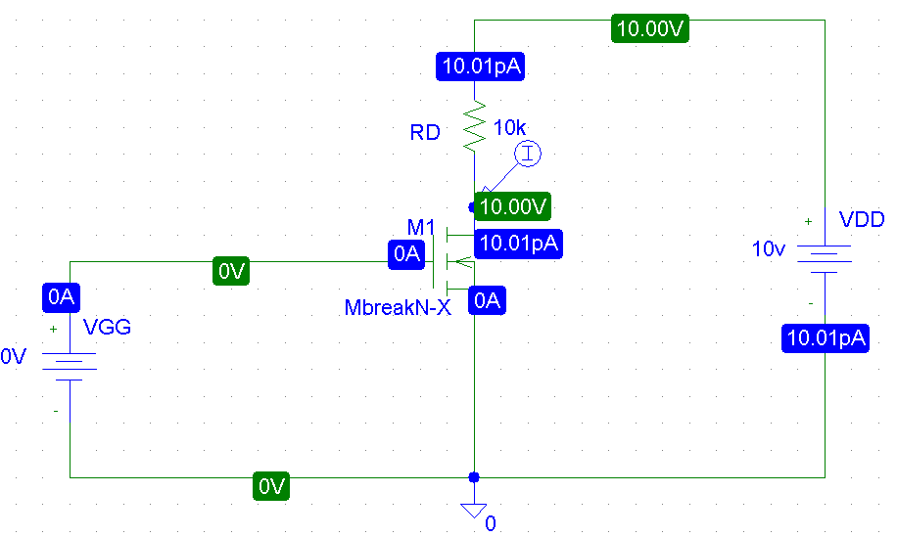

**Fig: N-channel MOSFET**

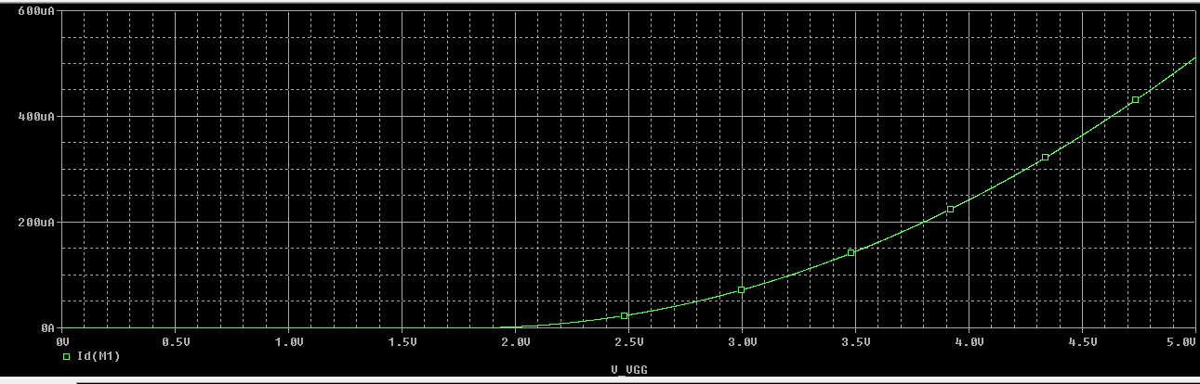

**Fig: ID-VGS Characteristics**

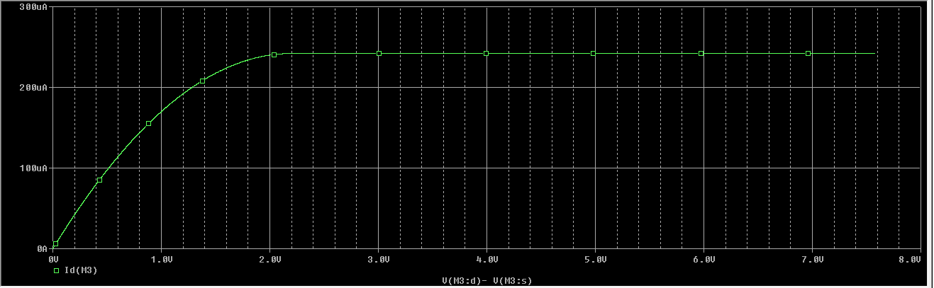

**Fig: ID-VDS Characteristics**

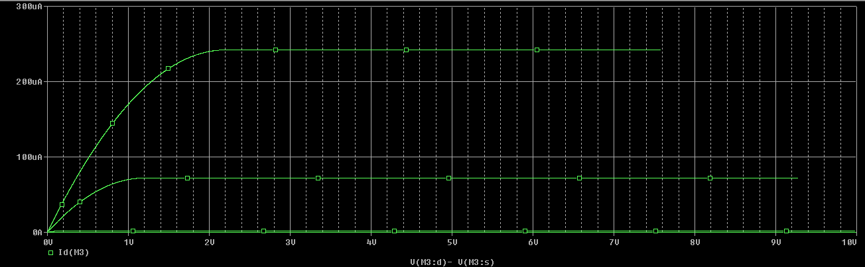

**Fig: ID-VDS Characteristics for multiple VGS**

**Simulation of a MOSFET dc circuit from textbook:**

**Reference:**

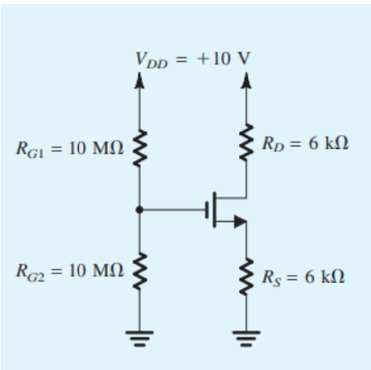

**Simulation:**

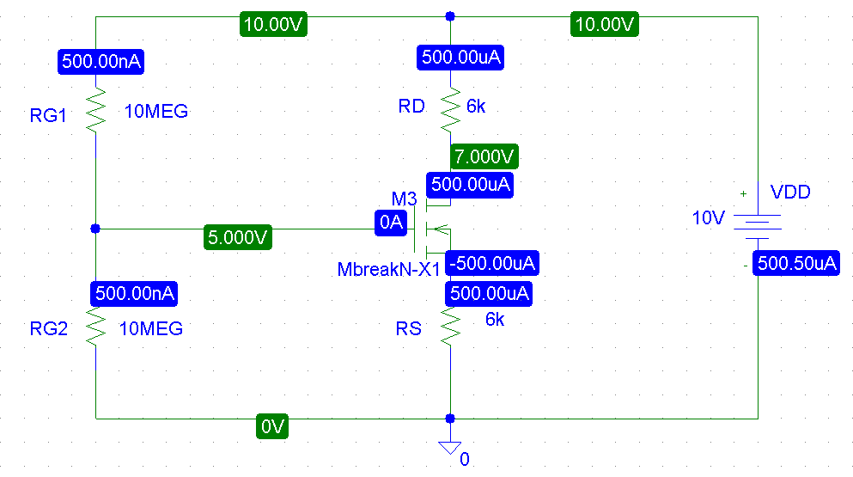

**Conclusion:**

From this experiment, we have learnt N-MOS charaterstics and Id-Vgs Characteristics, Id-Vds Characteristics of a circuits.